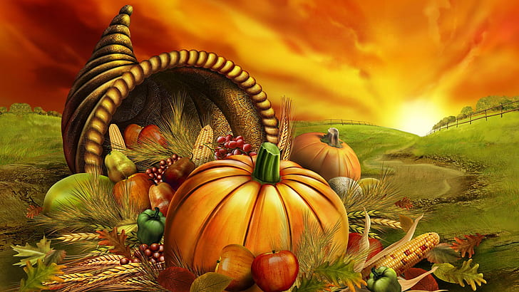

Month of November

Monday | Tuesday | Wednesday | Thursday | Friday
1.  Baked Veggie Pasta/  Garlic Bread  Fruit  Water/Milk | 2.  Veggie/Cheese Pizza  Juice/Water | 3.  Veggie Tacos  Lettuce and Cheese  Tater - Tots  Fruit Cup  Milk/Water | 4.  Stuffed Parantha  Butter  Yogurt  Dessert  Milk/Water | 5.  Kidney Beans  Rice  Yogurt  Fruit  Milk/Water
8.  Quesadilla w/ cheese & vegetables  Fruit  Milk/Water | 9.  Black Chick-Peas  Roti  Yogurt  Dessert  Milk/ water | 10.  Burrito with black beans, broccoli cheddar rice, cheese, lettuce, tomato & sour cream  Fruit Cup  Milk/ Water | 11.  No- School  (Veterans Day) | 12.  Veggie sub sandwich  Baked Chips  Juice/Water
15.  Veggie Cheeseburger  Lettuce/Tomato/Onion  Fries  Juice/Water | 16.  Veggie Tacos  Lettuce and Cheese  Tater - Tots  Fruit Cup  Milk/Water | 17.  Veggie/Cheese Pizza  Juice/Water | 18.  No- School | 19.  No- School
22.  Thanksgiving  Recess | 23.  Thanksgiving Recess | 24.  Thanksgiving Recess | 25.  Thanksgiving Recess | 26.  Thanksgiving Recess
29.  Veggie sub sandwich  Baked Chips  Juice/Water | 30.  Burrito with black beans, broccoli cheddar rice, cheese, lettuce, tomato & sour cream  Fruit Cup  Milk/ Water
Menu subject to change without notice

